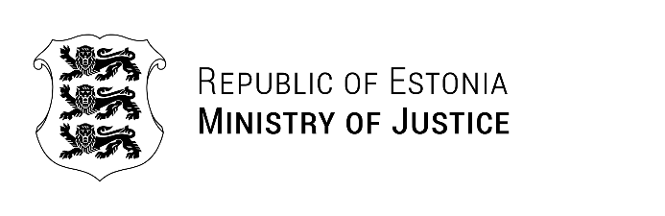

Estonian position on the Corporate Sustainability Due Diligence Directive (CSDDD)

Dear Dr. Marco Buschmann,

First of all allow me to thank You for your visit to Tallinn. We had fruitful discussions during the meeting and it is certainly a good start for our further deepened cooperation.

Your letter on the trilogue agreement on the proposal for a CSDDD contains very good explanations how we should protect our common values, but not to create bureaucratic regulations in the EU. We fully share your arguments and thereby Estonia is not underestimating the need for the greater protection of both human rights and the environment in economic activity. At the same time we also find that this goal should be achieved with clearly understandable and feasible measures which can also justify the accompanying administrative burden on the state and companies. This is not the case with the current outcome of the CSDDD proposal and therefore Estonia cannot either endorse the final outcome of the CSDDD. Estonia considers the interference with the principles of company law, the very broad scope and vague content of due diligence obligations and the application of civil liability to the violation of such obligations as most problematic among other aspects.

In my estimation over-regulation already restricts smart solutions and burdens businesses. I believe that EU needs clear rules and effective competition, but less administrative burden. Together we should focus on cutting red tape that unnecessarily burdens business and increases administrative burden.

Yours sincerely,

Kalle Laanet
Minister of Justice of Estonia

